EE 338: Filter Design Assignment

# Student Details

Name: Arunabh Ghosh

Roll Number: 150070006

Filter Number: 16

# Filter-1 (Bandpass) details

## Unnormalized Discrete time specifications

Filter number: 16

Since filter number is < 75, m = 16.

q(m) = greatest integer less than 0.1m = 1

r(m) = m – 10q(m) = 6

BL(m) = 5 + 1.4 q(m) + 4 r(m) = 30.4

BH(m) = BL(m) + 10 = 40.4

The first filter is given to be a Band-Pass filter with passband from BL(m) to BH(m) kHz. Therefore, the specifications are:

* Passband: 30.4 kHz to 40.4 kHz
* Transition band: 2 kHz on either side of passband
* Stopband: 0 to 28.4 kHz and 42.4 kHz to 150 kHz (Sampling rate is 300 kHz)
* Tolerance: 0.15 in magnitude for both Passband and Stopband
* Passband Nature: Monotonic
* Stopband Nature: Monotonic

## Normalized Digital Filter Specifications

Sampling rate: 300 kHz

In the normalized frequency axis, sampling rate corresponds to . Thus, any frequency (), up to 150 kHz can be represented on the normalized axis as:

Therefore, the corresponding normalized discrete filter specifications are:

* Passband: 0.20 to 0.27
* Transition band: 0.013 on either side of passband
* Stopband: 0 to 0.19 and 0.28 to (Sampling rate is 300 kHz)
* Tolerance: 0.15 in magnitude for both Passband and Stopband
* Passband Nature: Monotonic
* Stopband Nature: Monotonic

## Analog filter specifications for Band-pass filter using Bilinear transformation

The bilinear transformation is given as:

Applying the bilinear transformation to the frequencies at the band edges, we get:

|  |  |
| --- | --- |
|  |  |
| 0.20 | 0.32 |
| 0.27 | 0.45 |
| 0.19 | 0.31 |
| 0.28 | 0.47 |
| 0 | 0 |
|  |  |

Therefore, the corresponding analog filter specifications for the same type of analog filter using the bilinear transformation are:

* Passband: 0.32 to 0.45
* Stopband: 0 to 0.31and 0.47 to
* Tolerance: 0.15 in magnitude for both Passband and Stopband
* Passband Nature: Monotonic
* Stopband Nature: Monotonic

## Frequency transformation and relevant parameters

We need to transform a Bandpass analog filter to a Lowpass analog filter. We require two parameters in such a case. We can make use of the Bandpass transformation which is given as:

The two parameters in the above equation are B and . They can be determined using the specifications of bandpass analog filter using the following relations:

|  |  |
| --- | --- |
|  |  |
|  |  |
| 0.31 | -1.20 |
| 0.32 | -1.00 |
| 0.38 | 0 |
| 0.45 | 1.00 |
| 0.47 |  |
|  |  |

## Frequency transformed lowpass analog filter specifications

* Passband edge: 1
* Stopband edge: min ( = 1.20 (
* Tolerance: 0.15 in magnitude for both Passband and Stopband
* Passband Nature: Monotonic
* Stopband Nature: Monotonic

## Analog Lowpass Transfer function

We need an Analog Filter which has a monotonic passband and a monotonic stopband. Therefore, we need to design using the Butterworth approximation. Since the tolerance in both passband and stopband is 0.15, we define two new quantities in the following way:

Now using the inequality on the order N of the filter for the Butterworth Approximation we get:

The cut off frequency () of the Analog LPF should satisfy the following constraint:

Thus, we can choose the value of as 1.0375. Now, the poles of the transfer function can be obtained by solving the equation:

Solving for the roots (using Wolfram) we get:

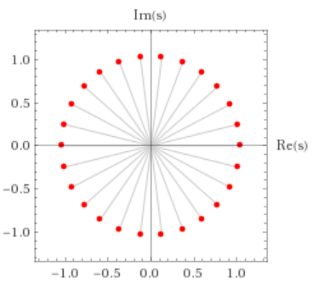

Note that the above figure shows the poles of the Magnitude Plot of the Transfer Function. To get a stable Analog LPF, we must include the poles lying in the Left Half Plane in the Transfer Function.

p1 = -1.00735 + 0.24829i;

p2 = -1.00735 - 0.24829i;

p3 = -0.918661 - 0.48215i;

p4 = -0.918661 + 0.48215i;

p5 = -0.77658 + 0.68799i;

p6 = -0.77658 - 0.68799i;

p7 = -0.589367 - 0.853846i;

p8 = -0.589367 + 0.853846i;

p9 = -0.367903 + 0.970079i;

p10 = -0.367903 - 0.970079i;

p11 = -0.125057 - 1.02994i;

p12 = -0.125057 + 1.02994i;

p13 = -1.0375;

Using the above poles which are in the left half plane we can write the Analog Lowpass Transfer Function as:

## Analog Bandpass Transfer function

The transformation equation is given by:

Substituting the values of B (0.13) and (0.38), we get:

To transform the analog domain transfer function into the discrete domain, we need to make use of

the Bilinear Transformation which is given as:

Using the above equations, we can obtain the .

## Realization using Direct Form II

Here are the coefficients of the numerator. The odd coefficients of z have value 0.

|  |  |  |  |  |  |  |
| --- | --- | --- | --- | --- | --- | --- |
|  |  |  |  |  |  |  |
|  |  |  |  |  |  |  |

|  |  |  |  |  |  |  |
| --- | --- | --- | --- | --- | --- | --- |
|  |  |  |  |  |  |  |
|  |  |  |  |  |  |  |

Here are the coefficients of the Denominator.

|  |  |  |  |  |  |  |
| --- | --- | --- | --- | --- | --- | --- |
|  |  |  |  |  |  |  |
|  |  |  |  |  |  |  |

|  |  |  |  |  |  |  |
| --- | --- | --- | --- | --- | --- | --- |
|  |  |  |  |  |  |  |
|  |  |  |  |  |  |  |

|  |  |  |  |  |  |  |
| --- | --- | --- | --- | --- | --- | --- |
|  |  |  |  |  |  |  |
|  |  |  |  |  |  |  |

|  |  |  |  |  |  |  |
| --- | --- | --- | --- | --- | --- | --- |
|  |  |  |  |  |  |  |
|  |  |  |  |  |  |  |

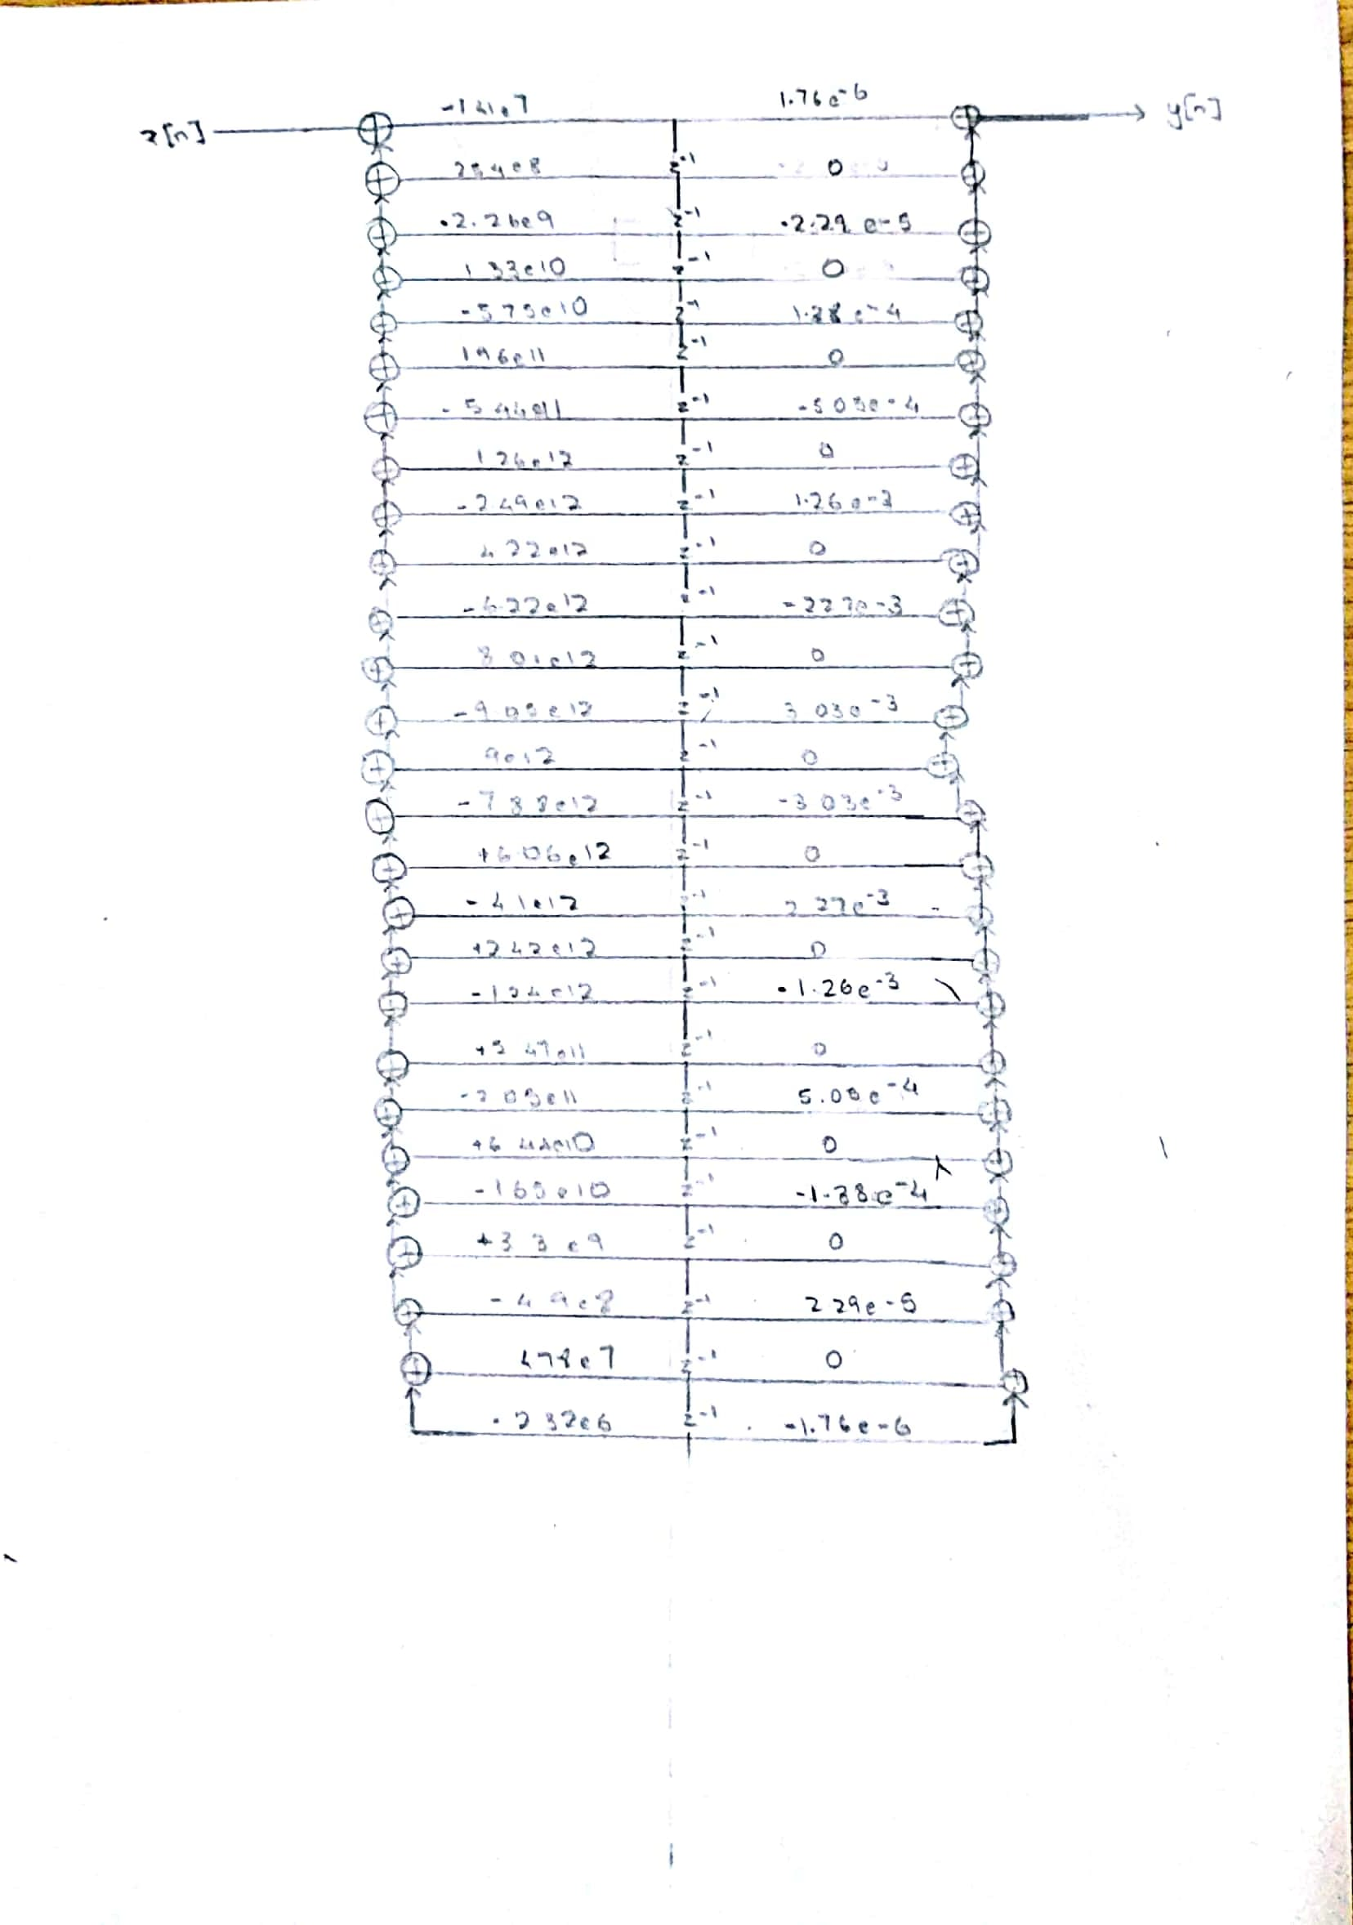

## FIR Filter Transfer Function using Kaiser Window

The tolerance in both the stopband and passband is given to be 0.15. Therefore = 0.15 and we get the minimum stopband attenuation to be:

Since A < 21, we get to be 0 where is the shape parameter of Kaiser window. Now to estimate the window length required, we use the empirical formula for the lower bound on the window length.

Here is the minimum transition bandwidth. In our case, the transition width is the same on either side of the passband.

This gives us A > 91. On successive trials in MATLAB, it was found that a window length of 92 is required to satisfy the required constraints. Also, since is 0, the window is a rectangular window.

The time domain coefficients were obtained by first generating the ideal impulse response samples for the same length as that of the window. The Kaiser Window was generated using the MATLAB function and applied on the ideal impulse response samples. For generating the ideal impulse response, a separate function was made to generate the impulse response of Low-Pass filter. It took the cut off value and the number of samples as input argument. The band-pass impulse response samples were generated as the difference between two low-pass filters as done in class.

Columns 1 through 15

0.0043 -0.0012 -0.0082 -0.0121 -0.0096 -0.0008 0.0099 0.0162 0.0141 0.0042 -0.0082 -0.0162 -0.0153 -0.0066 0.0044

Columns 16 through 30

0.0115 0.0113 0.0055 -0.0008 -0.0034 -0.0016 0.0012 0.0004 -0.0054 -0.0124 -0.0140 -0.0053 0.0116 0.0276 0.0313

Columns 31 through 45

0.0165 -0.0122 -0.0401 -0.0500 -0.0326 0.0060 0.0464 0.0656 0.0504 0.0062 -0.0448 -0.0746 -0.0657 -0.0214 0.0355

Columns 46 through 60

0.0746 0.0746 0.0355 -0.0214 -0.0657 -0.0746 -0.0448 0.0062 0.0504 0.0656 0.0464 0.0060 -0.0326 -0.0500 -0.0401

Columns 61 through 75

-0.0122 0.0165 0.0313 0.0276 0.0116 -0.0053 -0.0140 -0.0124 -0.0054 0.0004 0.0012 -0.0016 -0.0034 -0.0008 0.0055

Columns 76 through 90

0.0113 0.0115 0.0044 -0.0066 -0.0153 -0.0162 -0.0082 0.0042 0.0141 0.0162 0.0099 -0.0008 -0.0096 -0.0121 -0.0082

Columns 91 through 92

-0.0012 0.0043

The z-transform can be formed from the coefficients of this finite sequence.

# Filter-2(Bandstop) Details

## Un-normalized Discrete Time Filter Specifications

Filter number: 16

Since filter number < 75, m = 16.

q(m) = greatest integer less than 0.1m = 1

r(m) = m – 10q(m) = 6

BL(m) = 5 + 1.2 q(m) + 2.5 r(m) = 21.2

BH(m) = BL(m) + 6 = 27.2

The second filter is given to be a Band-Stop filter with stopband from BL(m) kHz to BH(m) kHz. Therefore, the specifications are:

* Stopband: 21.2 kHz to 27.2 kHz
* Transition band: 2 kHz on either side of passband
* Passband: 0 to 19.2 kHz and 29.2 kHz to 100 kHz (Sampling rate is 200 kHz)
* Tolerance: 0.15 in magnitude for both Passband and Stopband
* Passband Nature: Equiripple
* Stopband Nature: Monotonic

## Normalized Digital Filter Specifications

Sampling rate: 200 kHz

In the normalized frequency axis, sampling rate corresponds to .

This any frequency (), up to 150 kHz can be represented on the normalized axis as:

Therefore, the corresponding normalized discrete filter specifications are:

* Stopband: 0.21 to 0.27
* Transition band: 0.02 on either side of passband
* Passband: 0 to 0.19 and 0.29 to (Sampling rate is 300 kHz)
* Tolerance: 0.15 in magnitude for both Passband and Stopband
* Passband Nature: Equiripple
* Stopband Nature: Monotonic

## Analog filter specifications for Band-pass filter using Bilinear transformation

The bilinear transformation is given as:

Applying the bilinear transformation to the frequencies at the band edges, we get:

|  |  |
| --- | --- |
|  |  |
| 0.20 | 0.34 |
| 0.27 | 0.45 |
| 0.19 | 0.31 |
| 0.28 | 0.49 |
| 0 | 0 |
|  |  |

Therefore, the corresponding analog filter specifications for the same type of analog filter using the

bilinear transformation are:

* Stopband: 0.34 to 0.45
* Passband: 0 to 0.31and 0.49 to
* Tolerance: 0.15 in magnitude for both Passband and Stopband
* Passband Nature: Equiripple
* Stopband Nature: Monotonic

## Frequency Transformation & Relevant Parameters

We need to transform a Band-Stop analog filter to a Lowpass analog filter. We require two parameters in such a case. We can make use of the Bandstop transformation which is given as:

The two parameters in the above equation are B and . They can be determined using the specifications of the bandpass analog filter using the following relations:

|  |  |
| --- | --- |
|  |  |
|  |  |
| 0.31 | +1 |
| 0.34 | +1.6 |
| 0.39 |  |
| 0.39 |  |
| 0.45 | -1.48 |
|  |  |
|  |  |

## Frequency Transformed Lowpass Analog Filter Specifications

* Passband edge: 1
* Stopband edge: min ( = 1.48 (
* Tolerance: 0.15 in magnitude for both Passband and Stopband
* Passband Nature: Equiripple
* Stopband Nature: Monotonic

## Analog Lowpass Transfer Function

We need an Analog Filter which has an equiripple passband and a monotonic stopband. Therefore, we need to design using the Chebyshev approximation. Since the tolerance () in both passband and stopband is 0.15, we define two new quantities in the following way:

Now choosing the parameter of the Chebyshev filter to be , we get the minimum value of N as:

Now, the poles of the transfer function can be obtained by solving the equation:

Solving for the roots (using Wolfram) we get:

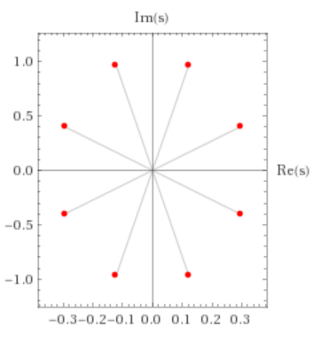

Note that the above figure shows the poles of the Magnitude Plot of the Transfer Function. To get a stable Analog LPF, we must include the poles lying in the Left Half Plane in the Transfer Function.

p1 = -0.12216 - 0.96981i;

p2 = -0.12216 + 0.96981i;

p3 = -0.29492 + 0.40171i;

p4 = -0.29492 - 0.40171i;

Using the above poles which are in the left half plane and the fact that N is odd we can write the Analog Lowpass Transfer Function as:

Note that since it is even order we take the DC Gain to be

## Analog Bandstop Transfer Function

The transformation equation is given by:

Substituting the values of the parameters B and , we get,

Substituting this value in we get .

## Discrete Time Filter Transfer Function

To transform the analog domain transfer function into the discrete domain, we need to make use of the Bilinear Transformation which is given as:

Using this equation, we get from .

## Realization using Direct Form II

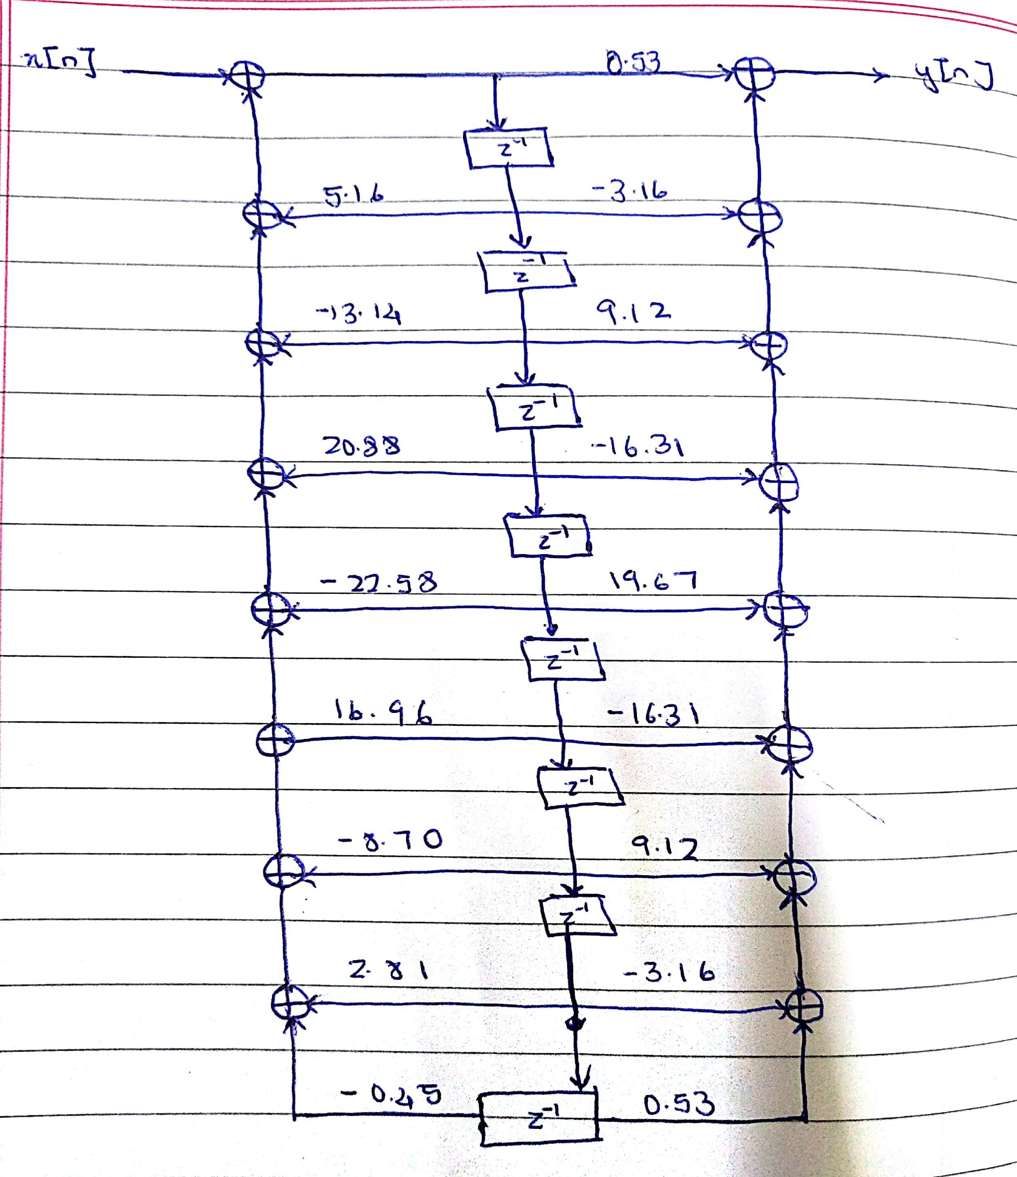

## FIR Filter Transfer Function using Kaiser Window

The tolerance in both the stopband and passband is given to be 0.15. Therefore = 0.15 and we get the minimum stopband attenuation to be:

Since A < 21, we get to be 0 where is the shape parameter of Kaiser window. Now to estimate the window length required, we use the empirical formula for the lower bound on the window length.

Here is the minimum transition bandwidth. In our case, the transition width is the same on either side of the passband.

This gives us A > 60. The above equation gives a loose bound on the window length when the tolerance is not very stringent. On successive trials in MATLAB, it was found that a window length of 85 is required to satisfy the required constraints. Also, since is 0, the window is a rectangular window.

The time domain coefficients were obtained by first generating the ideal impulse response samples for the same length as that of the window. The Kaiser Window was generated using the MATLAB function and applied on the ideal impulse response samples. For generating the ideal impulse response, a separate function was made to generate the impulse response of Low-Pass filter. It took the cut off value and the number of samples as input argument. The band-stop impulse response samples were generated as the difference between three low-pass filters (all-pass - bandpass) as done in class.

Columns 1 through 11

0.0124 0.0123 0.0047 -0.0068 -0.0155 -0.0160 -0.0074 0.0053 0.0148 0.0158 0.0082

Columns 12 through 22

-0.0026 -0.0101 -0.0105 -0.0053 0.0004 0.0022 0.0000 -0.0024 -0.0004 0.0068 0.0145

Columns 23 through 33

0.0151 0.0043 -0.0146 -0.0306 -0.0315 -0.0125 0.0190 0.0454 0.0492 0.0242 -0.0187

Columns 34 through 44

-0.0561 -0.0651 -0.0375 0.0136 0.0605 0.0761 0.0498 -0.0050 -0.0582 0.9200 -0.0582

Columns 45 through 55

-0.0050 0.0498 0.0761 0.0605 0.0136 -0.0375 -0.0651 -0.0561 -0.0187 0.0242 0.0492

Columns 56 through 66

0.0454 0.0190 -0.0125 -0.0315 -0.0306 -0.0146 0.0043 0.0151 0.0145 0.0068 -0.0004

Columns 67 through 77

-0.0024 0.0000 0.0022 0.0004 -0.0053 -0.0105 -0.0101 -0.0026 0.0082 0.0158 0.0148

Columns 78 through 85

0.0053 -0.0074 -0.0160 -0.0155 -0.0068 0.0047 0.0123 0.0124

# MATLAB Plots

## Filter 1 – Bandpass

### IIR Filter

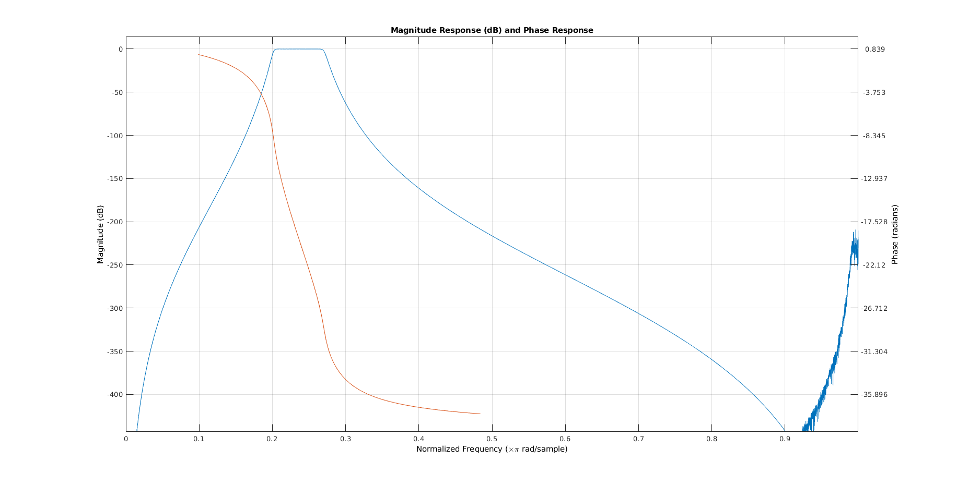

Figure 1: Frequency Response

From the above plot, I have verified that the passband tolerance and stopband attenuation have been satisfied. The phase response is not linear.

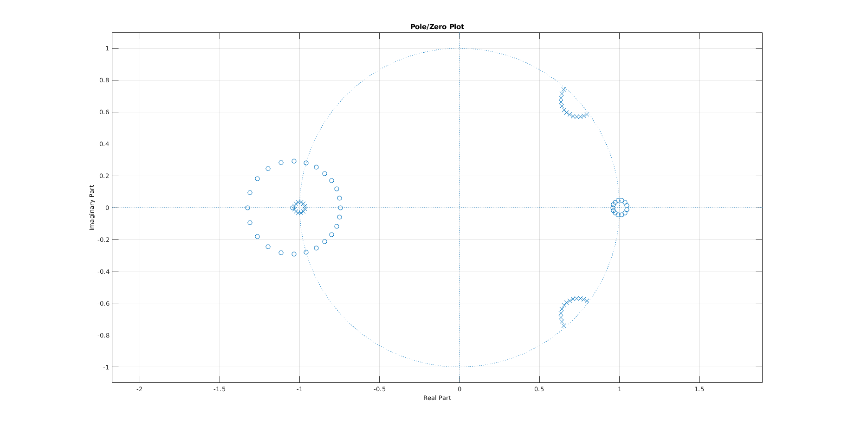

Figure 2: Pole-Zero map (all poles within unit circle, hence stable)

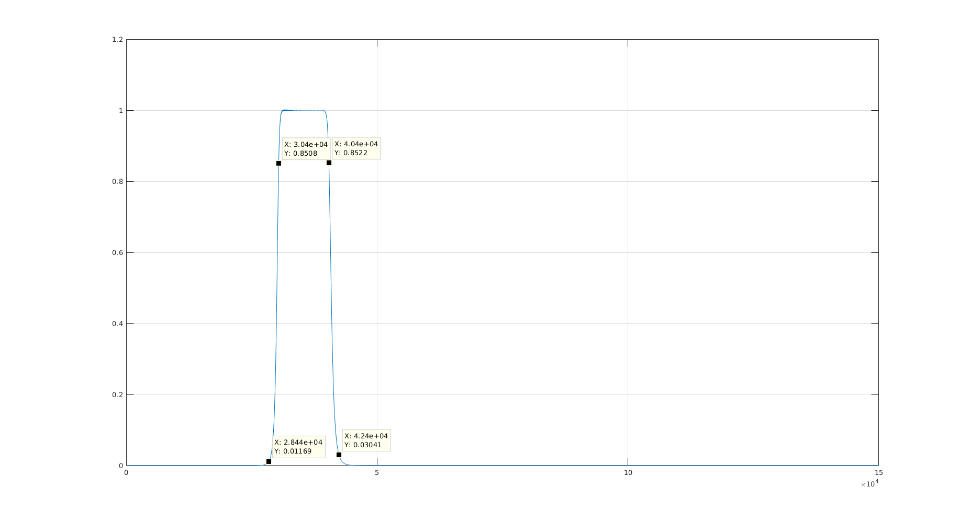

Figure 3: Magnitude Plot

In the above plot, the band edge frequencies have been marked. From the magnitude at these frequencies, the specifications required in the passband and the stopband have been met.

### FIR Filter

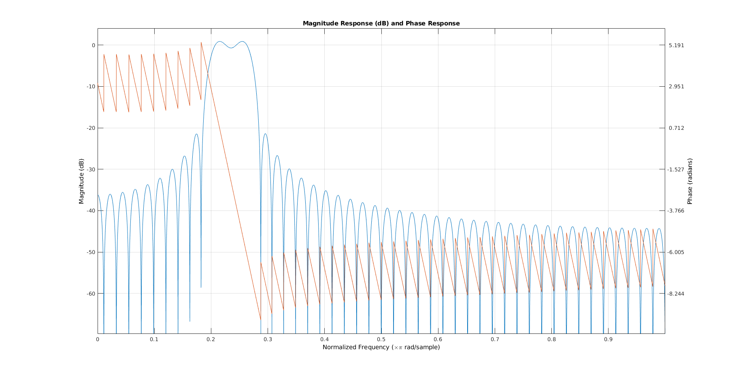

Figure 4: Frequency Response

From the above plot, I have verified that the passband tolerance and stopband attenuation have been satisfied. The FIR Filter is indeed giving us a Linear Phase response which is desired.

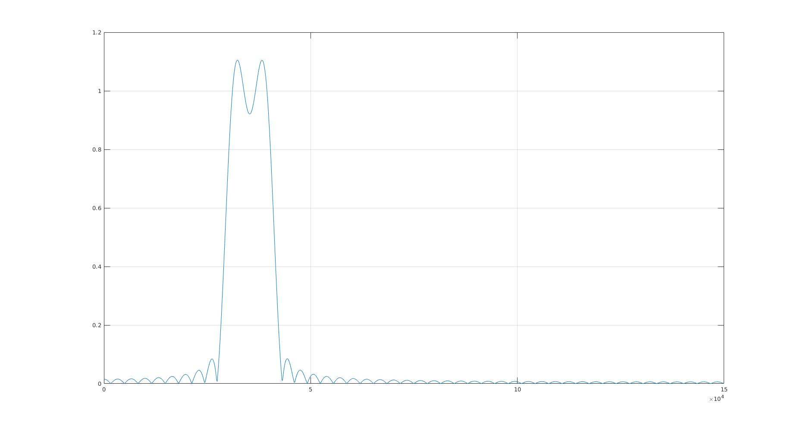

Figure 5: Magnitude Plot

In the above plot, the band edge frequencies have been marked. From the magnitude at these frequencies, it can be seen that the specifications required in the passband and the stopband have been met.

## Filter 2 – Bandstop

### IIR Filter

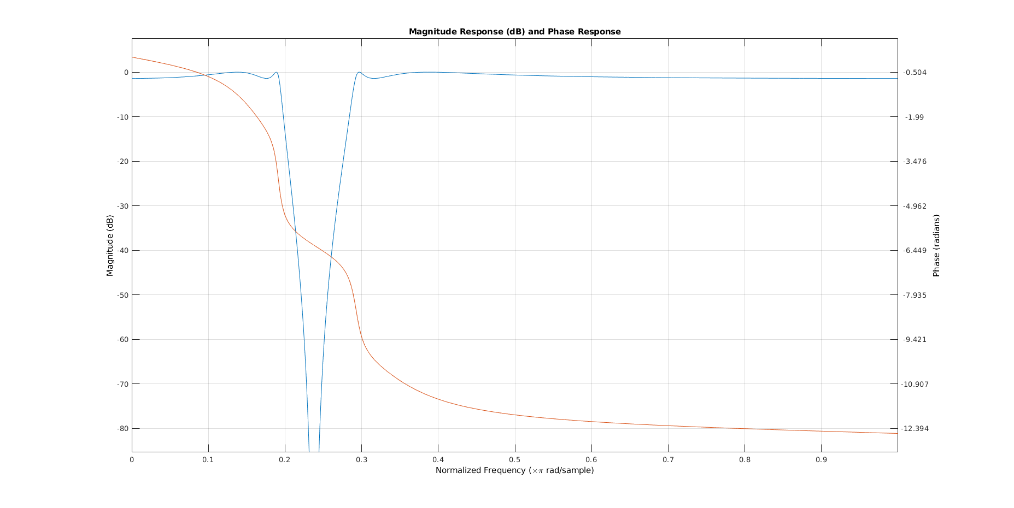

Figure 6: Frequency response

From the above plot, I have verified that the passband tolerance and stopband attenuation have been satisfied. The phase response is not linear.

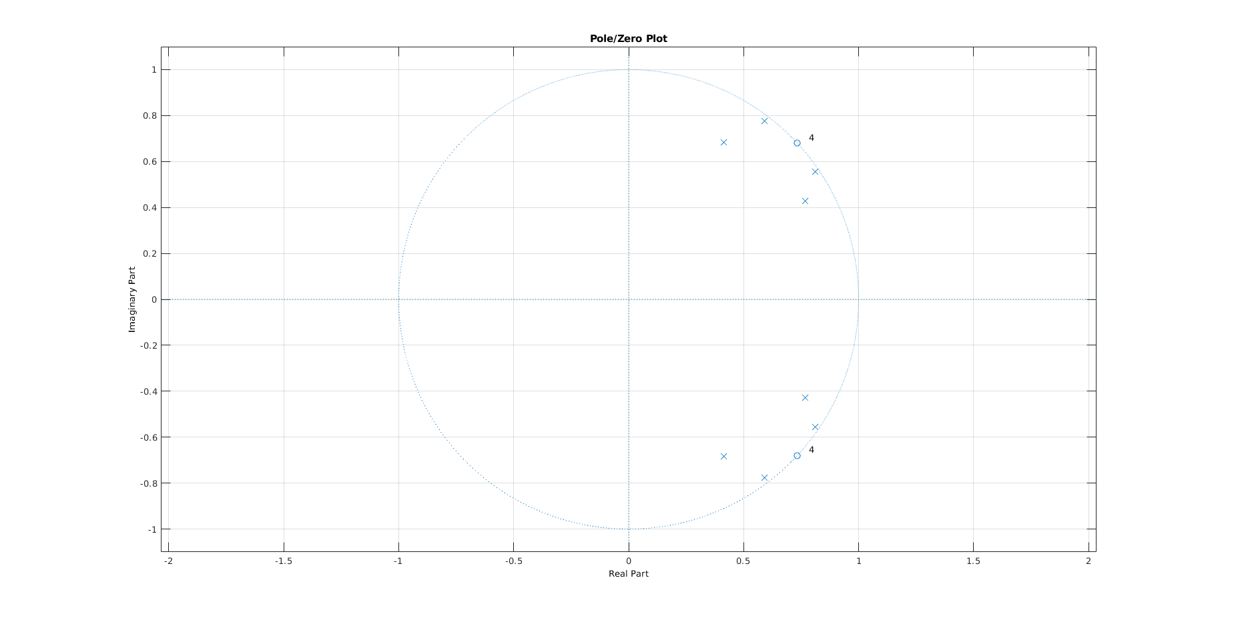

Figure 7: Pole-Zero map (all poles within unit circle, hence stable)

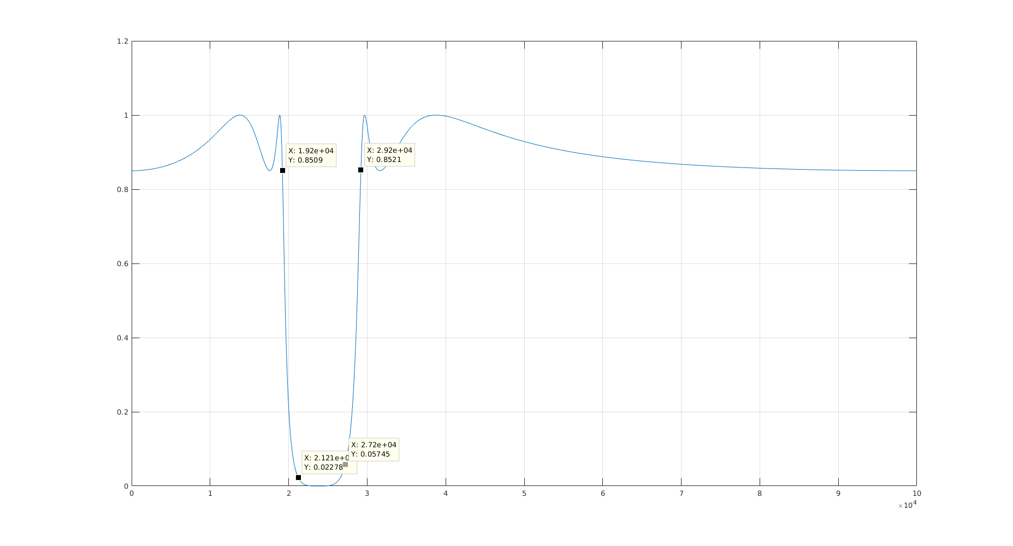

Figure 8: Magnitude Plot

In the above plot, the band edge frequencies have been marked. From the magnitude at these frequencies, the specifications required in the passband and the stopband have been met.

### FIR Filter

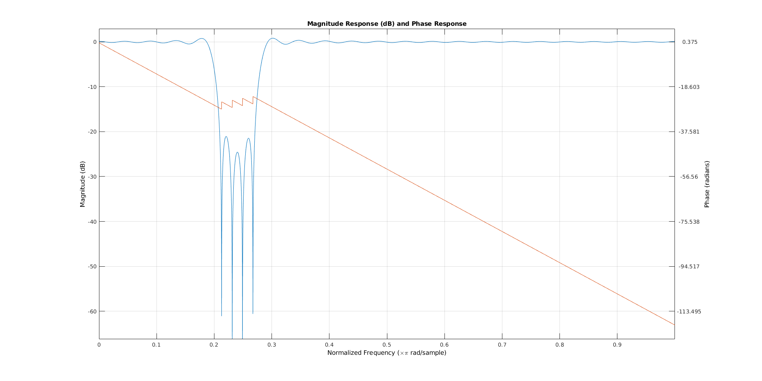

Figure 9: Frequency Response

From the above plot, I have verified that the passband tolerance and stopband attenuation have been satisfied. The FIR Filter is indeed giving us a Linear Phase response which is desired.

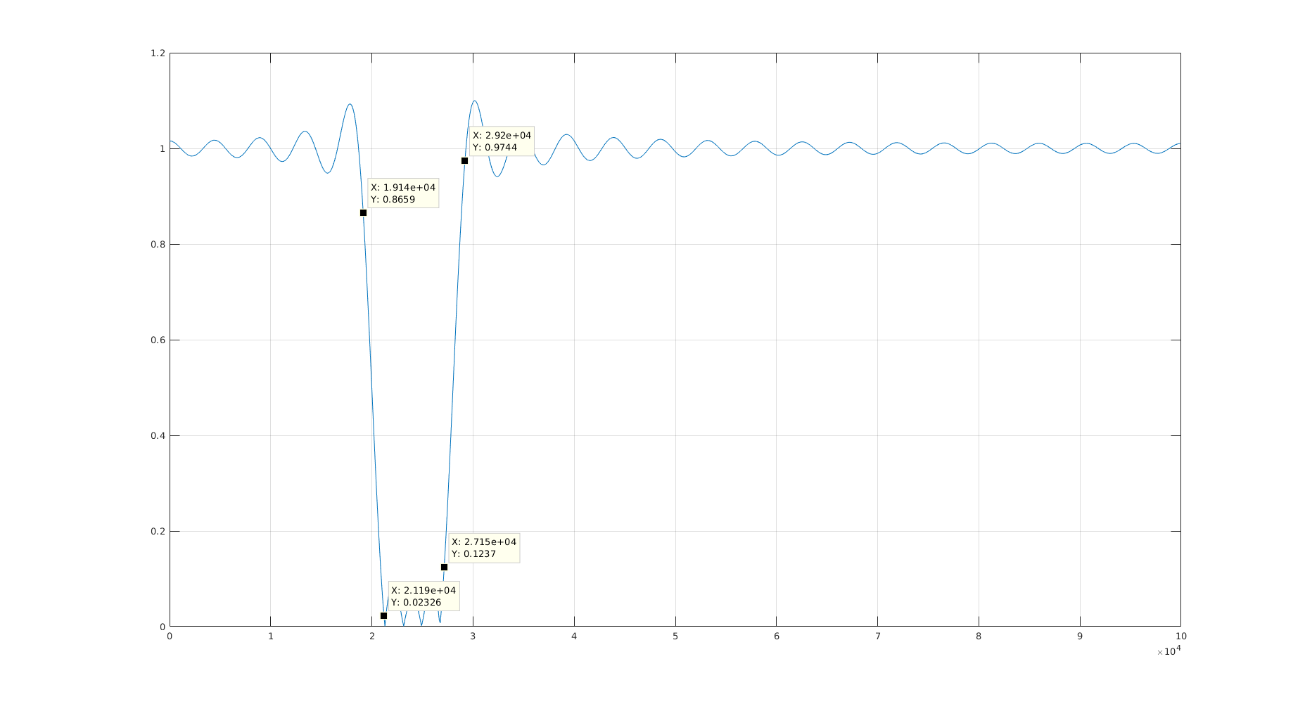

Figure 10: Magnitude Plot

In the above plot, the band edge frequencies have been marked. From the magnitude at these frequencies, it can be seen that the specifications required in the passband and the stopband have been met.